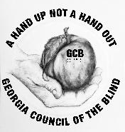
The logo picture is inside a light-yellow circle, with words at the top and bottom in large, upper case, bold black letters. The top of the circle reads, ‘A HAND UP NOT A HANDOUT.’ Under the circle, the words are, ‘GEORGIA COUNCIL OF THE BLIND.’ In the center of the circle is a pencil drawing in gray tones. It is a palm of an open right hand cradling a Georgia peach. At its top, from the left side of a short brown stem, a thin green leaf hangs down and over the thumb. The peach has colors like the warmth of the sun. The vivid yellow and orange colors contrast with the black, upper case letters GCB in the middle of the peach, with corresponding Braille dots directly under the three letters.

The GCB DIGEST
A publication of the Georgia Council of the Blind
An affiliate of the American Council of the Blind,
An organization promoting a hand up and not a handout.
Fall 2022
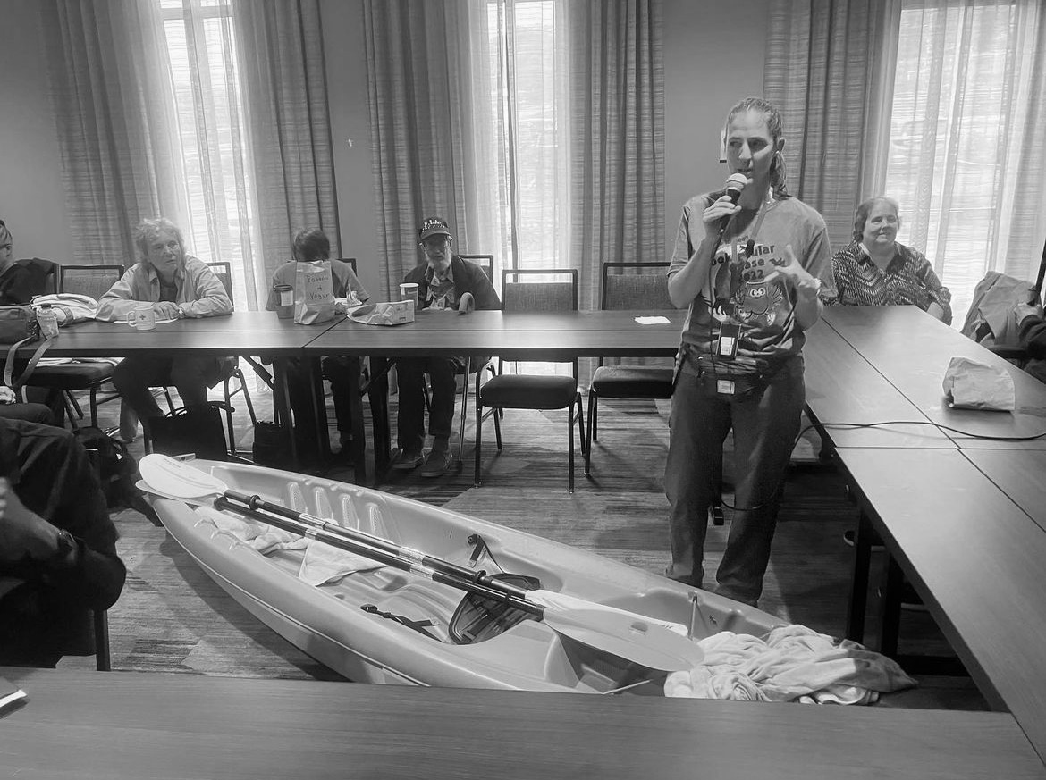
This picture contains the following people from left to right:
Jeannette Sickel, Ann Martin, Robert Martin, speaker Nancy Barkin-Bashizi and Penny Moss pictured with a kayak
.

GCB Officers for 2021-2024:
Cecily Laney Nipper, GCB President, 470-218-7885, roses828@comcast.net
Marj Schneider, GCB First Vice-President, 912-352-1415, marjschneider@bellsouth.net
Judy Presley, GCB Second Vice-President, 706-878-2962, hoyal@windstream.net
Kathy Morris, GCB Secretary, 706-466-2253, mkumorris@yahoo.com
Cecily Nipper, Senior, GCB Assistant Secretary, 770-786-1551, sparklenipper@gmail.com
Marsha Farrow, GCB Treasurer, 706-859-2624, marshafarrow@windstream.net
Betsy Grenevitch, GCB Member at Large Representative, 678-862-3876, blindangel61@gmail.com
Amanda Wilson, Digest Editor, 770-547-4700, moonrocks@bellsouth.net
Janet Parmerter, Assistant Editor, 770-733-1853, Janet@ParmerTours.com

Table of Contents:
From Your Editor
GCB Presidential Message
GCB Chapter News
Georgia Guide Dog Users News
GCB Community Phone Calls
GCB Peach Talk
Apply for a GCB Scholarship
2022 American Council of the Blind, ACB Convention Experience
Voting: It Was an Experience
GCB Conference and Convention Overview
Georgia Council of the Blind Convention Comments
Our Octogenarian Odyssey

From Your Editor,
By Amanda Wilson

Hello, GCB family. We thank each one who has submitted articles in this issue of our magazine. If you have any change of address, telephone number, email address or desired change of format, please inform our GCB treasurer.
Thanks to everyone who makes our GCB Digest such a considerable success. Particularly, I want to thank Janet Parmerter, Assistant Editor, for her editing skills and for the many hours she has worked on the magazine. In addition, I want to thank our President Cecily Laney Nipper, for her presidential message with information about momentous events, legislation, and projects. Also, I appreciate the contributions from our new GCB Digest committee, each member who sent articles, and those who made suggestions.
Note: The GCB Digest is now on NFB Newsline and on the Georgia Radio Reading Service, GARRS.
﻿
The Georgia Council of the Blind has a new Instagram account! Please check it out! To find it, search on Instagram for gacounciloftheblind. That represents ‘GA Council of the Blind’ without spaces and in all lower-case letters.

GCB Presidential Message
By Cecily Laney Nipper

Looking back at GCB’s recent annual Conference and Convention held in Cartersville, Georgia, and seeing old friends, making new ones, and celebrating our veterans were just a few of the highlights. Those who organized the event, those who gave of their time to participate, exhibit, volunteer, or attend on Zoom all contributed to the overall success of the event. The greater community received recognition from resolutions passed, which thanked the hotel and the conference center as well as those who served us as teachers and volunteers. They all received recognition in our state awards, and we also reached into our own ranks to recognize one another in heartfelt ways.

Everyone was inspired on Friday night, as guest speaker Tyson Ernst, described how we as people who are blind or have low vision, must equip ourselves for the battles we face. The patriotic overtones in the room culminated Saturday in a resolution which unanimously passed, to seek to place a bronze braille flag in the Georgia state Capitol in honor of our own Fred McDade, who served our country during the Vietnam era at great physical and personal cost. As he spoke words of appreciation to the Georgia Council for this honor, which truly is the least we could do for such a hero in our midst, many eyes were wet in the room.

As part of that ongoing battle for representation and services, GCB passed a fourth resolution to pursue a commission, a goal which was almost reached during the past legislative session. The Georgia Vision Alliance will be back in force starting on December 3, 2022, with efforts to reintroduce legislation to grant Georgia a commission for the blind so that we may have services targeted toward us and counselors trained to provide services to our community. The Georgia Council of the Blind will be represented on the commission by me, as well as by commission president, Alice Ritchhart. The Georgia Council of the Blind is united in its purpose to, “elevate the social, economic, and cultural levels of the blind.” The resolutions committee, chaired by Alice Ritchhart, deserves our appreciation for presenting concise, well-written resolutions that help us come from the convention with a renewed sense of purpose for the fight ahead.
As your president, I seek to serve the needs of this organization and all of you, so please feel free to reach out to me with comments or concerns, especially about the direction of GCB’s advocacy efforts. A happy and healthy holiday season to each of you as we close out 2022 and start a new year!

GCB Chapter News
The Athens Chapter:
The Athens Chapter reported they held their Christmas Party on Saturday, December 10, 2022, at 11:30 AM, at the Hilltop Grille Which is located at 2310 W Broad St in Athens Georgia. The Athens chapter meetings are held by conference call at present on the fourth Saturday of every month at 10:30 AM. The call-in number is 605-313-4818 and the access code is 463476#.
The Athens Chapter meetings are held at the WHEELS of HOPE office which is located at 367 Prince Avenue in Athens, Georgia, 11:00 AM.
For more information about the Athens Chapter please contact Jerrie Toney at (706) 461-1013 or jerriemt2@gmail.com.

The Augusta Chapter:
The Augusta Chapter reported that they held their elections in October of this year. The following officers were elected: Ronald Worley as president; Stanley Lopez as vice-president; Deborah Lovell as secretary; and Kathy Morris as treasurer. The Augusta Chapter held their Christmas party on Tuesday, December 6, 2022, at Logans restaurant. The Augusta chapter hopes that everyone will have a beautiful and safe holiday season.
For more information about the Augusta Chapter, please contact Deborah Lovell at 706-726-4054, or via email at lovell.d2000@gmail.com.

East Georgia Chapter:
The East Georgia Chapter reported that in June the East Georgia Chapter excitedly resumed in person meetings! They welcomed special guest speaker Rachel Ruckart, Director of GARRS. There was no meeting held in July per the norm for the chapter. In August they held our annual picnic. They played trivia and had an egg race. Lots of laughs were had and they all enjoyed an excellent lunch catered by a local Conyers eatery, The Sandwich Factory. The chapter also gifted a local resident in need, Ms. Ruth Ann, with an Eyoyo - a handheld video digital magnifier. This will help make her life just a little easier. In October they were extremely excited to welcome local Newton County Sheriff’s Department officer Joseph Lightsey. He presented on how to stay safe as a senior or person with a disability as well as how to interact with the police. November’s meeting included a recap of the 2022 Conference and Convention since several members were able to attend. Also, in November guide dog Shadow went to school! Shadow and Cecily Laney Nipper had the opportunity to present to the class of Michelle Grenevitch at Social Circle Elementary. The science class was able to learn all about guide dogs and their inherited and learned traits. At their December meeting they are having a Christmas program. They will be decorating jars and filling them with hot cocoa mix and marshmallows. They normally have a Christmas dinner, but this year some members will just be bringing pre-packaged treats or finger style foods instead of entrees and sides. The East Georgia Chapter meets in person at Conyers Presbyterian Church and via Zoom the 2nd Saturday of every month.
For more information about the East Georgia Chapter, please contact Cecily Laney Nipper, at 470-218-7885, or via email at roses828@comcast.net.

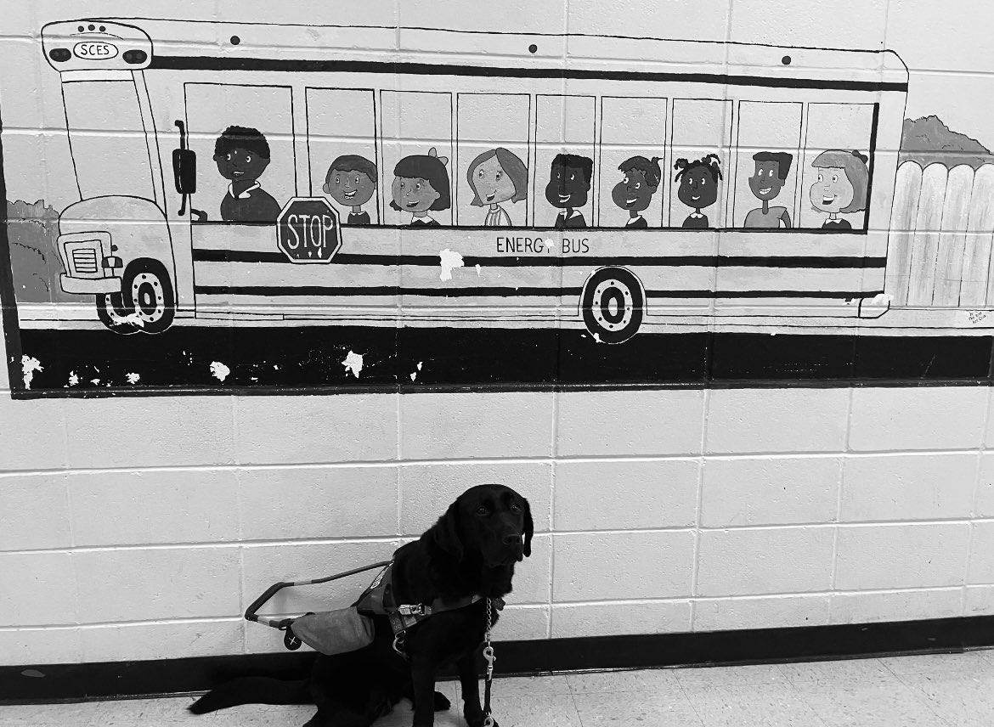
Guide Dog Shadow at school

Greater Hall County Chapter:
The Greater Hall County Chapter reported at their September meeting, Judy Presley was their speaker and shared her experiences and adventures at the 2022 American Council of the Blind ACB Convention in Omaha, Nebraska. Judy has included a separate article to be featured in the GCB Digest with her perspective from that week. At their October meeting they welcomed back Republic of Panama students, Juliannet and Herves, as their guest speakers. They shared highlights from their year of intensive language study at Breneau University in Gainesville, Georgia. They included poignant accounts of their struggles and achievements along with hope for the future as they return home in December. At their November meeting their guest speaker was Cheryl Saucier, Rehabilitation Specialist and CEO of Mountain View Low Vision Services in Chattanooga, Tennessee. She discussed obstacles facing the blind community as, year after year, vision assistance legislation is introduced but not passed. She shared ideas that various groups are implementing to reach their communities with assistive devices. Cheryl discussed trends to watch for in coming months with vision technology: wearables, transportability, versatility, and simplicity. She demonstrated items including the Orcam Read and My Pocket Phone. For their December meeting they will meet at O’Charley’s Restaurant in Gainesville, Georgia, for a Christmas luncheon of food, fun and Carols. A Note of Interest: During the 2022 midterm election cycle, some of our members chose to vote in-person using the handicap-accessible voting machines for the first time. Some reported a smooth voting experience, but others experienced machine malfunctions or lack of accessibility at the precinct. The problems were reported to the Voter Elections Office. The Voting Director expressed her thanks for the feedback from our members and stressed that if we encounter a problem, she needs to know about it, and said the failures will be addressed and rectified before our next election. Our guest speakers are live-streamed each month by treasurer, Roy Carder. Archived videos can be viewed on our Facebook page, Greater Hall GCB.
The Greater Hall County Chapter meetings are held on the second Saturday of each month, from 10:30 AM until 12:00 PM, at Smoky Springs Retirement Residences, which is located at 940 South Enota Drive in Gainesville, Georgia. For more information, please contact Judy Presley at 706-400-2185 or via email at hoyal@windstream.net.

The Northwest Georgia Chapter:
The Northwest Georgia Chapter reported they held their Christmas party on Tuesday, December 13, 2022, at 2:00 PM, at the Choo Barbecue in Chickamauga, Georgia.
For more information about the Northwest Chapter, please contact Sharon Nichols at 423-255-4551, or via email at sharonnichols347@icloud.com.

The Rome Floyd County Chapter:
The Rome Floyd County Chapter reported that they have not reported in a while, so they are going to tell you what they have been doing lately. They have had many speakers to come talk to them either on the phone or in person. Cecily Laney Nipper was on one of their phone calls and shared some of her projects and plans as the newly elected President of GCB. Betsy Grenevitch and DJ McIntyre were on one of the phone calls and shared what was going on with the Commission of the Blind Bill. They went to Dana’s house for a summer picnic. They met in person at Sam Burger deli for a fall luncheon.
For more information about the Rome Floyd County Chapter, please contact Amanda Wilson at 770-547-4700, or via email at moonrocks@bellsouth.net.

The Savannah Chapter:
For more information about the Savannah Chapter, please contact Marj Schneider at 912-352-1415, or via email at marjschneider@bellsouth.net.)

The South Metro Chapter:
For more information about the South Metro Chapter, please contact Brent Reynolds at 404-814-0768, or via email jbr53@samobile.net.

Georgia Guide Dog Users News
By Marj Schneider

On Friday, November 11, as part of the GCB conference and convention, Georgia Guide Dog Users members and guests heard speakers from K9 Battle Buddies, an organization on the Georgia coast which trains service dogs and veterans with PTSD and traumatic brain injury. Patricia Durham, cofounder of K9BBV and Tank, the organization’s current president, described how the program began in 2015 with the recognition that rescue dogs had the potential to be trained to meet the needs of disabled veterans, and those veterans themselves could participate in that training as they bond with a dog that mitigates the anxiety and stress resulting from their experience in battle. Their website describes it best. “K9 Battle Buddies was founded by a Combat Veteran who suffers from PTSD and understands the effects PTSD can have on everyday life. PTSD has affected everyone on our board in one form or another. Through our own personal struggles with PTSD, we understand first-hand about PTSD and the devastation it has on the veteran and the Veteran’s family. It is our honor to rehabilitate, train, and place dogs with a Combat Veteran suffering from PTSD and/or TBI.

Our goal is to get the Veteran involved in training their dog, starting with basic obedience, and then specific training based on their individual needs. This proven method allows a closer bond between the dog and their Veteran. The Veteran is given a list of short and long-term goals for their dog, and then they practice what they have learned when they are home. Our volunteer trainers then test the progress of the dog and Veteran upon the return to the training class. We believe this will create a stronger bond between dog and their Veteran."
For more information about the Georgia Guide Dog Users group, please contact Marj Schneider, 912-352-1415 or via email at marjschneider@bellsouth.net
.

GCB Community Phone Calls:
The Georgia Council of the Blind is holding community phone calls. The phone number for all the GCB community calls is 1-605-562-0400, and the access code is 780-5751, followed by the pound sign. If you cannot get in, then use the alternative phone number. It is 1-717-275-8940 and the access code is 7805751, followed by the pound sign.
Here is the schedule for GCB community phone calls.
Praise and Prayer:
Mike Hall will lead us in praise and prayer on the third Tuesday of the month at 7:00 PM.
GCB Book Club:
Debra Lovell and Judy Presley
Since the COVID epidemic, our GCB book club has been active for several months and we have read a wide variety of books. These include fiction, nonfiction, as well as biographies. Sometimes when you read a delightful book, you feel like you just must share it with others. This is what makes book clubs so much fun. That is why we encourage our members to suggest their favorite books and would love to have other book lovers out there to join us. We meet the fourth Thursday of each month at 7:30.
GCB Peach Talk
From the Membership and Project Committee:
The membership committee has started an ACB community room call and meet on the third Thursday from 7:30 until 8:30 PM.
In September, we talked about our favorite books and listed some authors from Georgia. In October we discussed our favorite Halloween parties, costumes, and our favorite memories. In November, we discussed our favorite music movies and tactile art and wrote an extensive list of singers from Georgia. In December we will discuss our favorite Christmas traditions.

Apply for a GCB Scholarship
By Marj Schneider

Each year the Georgia Council of the Blind awards several scholarships of up to $1000, through the Al and Cora Camp Memorial Scholarship Fund, supporting blind and partially sighted students in their academic pursuits.
Scholarships will once again be awarded by GCB in the spring of 2023. Please share this information with high school and college students who are blind or visually impaired throughout the State of Georgia and encourage them to visit the GCB website for the scholarship application and guidelines. Applications are due by March 1, 2023.
GCB also offers its members the opportunity to apply for a leadership scholarship. This scholarship provides financial support to GCB members who want to attend seminars or other training opportunities to develop their leadership skills. Updated guidelines and procedures to apply for the leadership scholarship are available on the GCB website. Applications for leadership scholarships can be submitted at any time.

2022 American Council of the Blind, ACB Convention Experience
By Judy Presley

This past July I was privileged to attend the ACB National Convention in Omaha, Nebraska. One of my favorite parts of the convention is always the morning sessions from 8:30 A.M. until 12:00 P.M. This is when the most interesting information about ACB and the world of blindness (across the US and worldwide) is shared. The exhibit hall was a super place to learn about the latest in assistive devices and everything imaginable pertaining to vision impairment. The exhibit hall included approximately seventy-five exhibitors. Of course, my favorite part of the convention was the pre-planned adaptive tours. It was heartwarming to encounter all the kind and caring volunteers who helped us find our way around the hotel and on the tours. The last two days of the convention I came down with what I thought was a bad cold. I evaluated it when I returned home and discovered it was really COVID. I was extremely ill and had no way to get to a nearby drug store to buy cold medicine. Since I have AIRA on my smartphone, the agent signed me up with DoorDash. The DoorDash driver purchased Tylenol daytime and nighttime cold medicines then, within 30 minutes delivered them to my hotel room door. To save on expenses, I shared a room with Marsha Farrow and her cousin, Debbie, and for me, all the laughing we did was good medicine. It is not always possible to attend every ACB National convention, but I would dearly love to attend each one. If it is possible, I encourage everyone to attend the ACB national convention to benefit themselves and also their chapter.

Voting: It Was an Experience!
By Mike Hall

How did you vote during the recent November mid-term election? No, I'm not asking who you voted for, but I will give you a hint as to which candidate I chose for the U.S. Senate. Just read to the end of this article for the clue. What I am actually after is what method of voting did you use. Did you complete an absentee ballot, vote in person with assistance, or use one of the accessible voting machines?

My voting experience began when I was eighteen in 1972. Yes, I am getting older, and I do remember the moon landing. Since that time, there have probably been no more than two or three elections I have missed. It was my mom who assisted me in voting in all of the elections except for one. Sometime in the 1990's, the local newspaper wanted to do a story about how I could vote as a person who is blind. To provide a good picture for the story, I asked a former teacher to accompany the Gainesville Times reporter and me to the polls.

There have been all kinds of voting machines. It was said that one of the early voting machines looked a lot like a slot machine, and I can remember when we would physically mark the ballot. There was a machine for a while with all kinds of switches that you flipped to choose your candidate for each office. But it was the first touch screen that got me in trouble. My mom was having me touch the screen with my finger. My thumb got in the way, and I voted for the opposing candidate. When a friend got word of it, he told everyone that I voted for that candidate twice. Needless to say, we made the correction.

When it came to the November election, my original plan was to vote on an absentee ballot, which I had done for the past couple of years. Three things changed my plan. First of all, I misplaced my absentee ballot. That was not good. Secondly, I began hearing radio commentators and others encouraging people to vote in person. Without getting into the concern about which form of voting is more secure, I'll just say that I missed voting in person, being around other people in my community who were also voting and seeing the poll workers who remembered me from the last election. The third thing that clenched my decision was an informative conversation I had with Greater Hall Chapter president Dianne Roberts.
Over the phone, Dianne and I talked at length about the accessible voting machine, which was brought to our chapter on a couple of occasions for demonstration. A couple of us were allowed to play with it. I struggled a little with the controller keyboard, which Dianne calls a Game Boy controller, because they have a similar look. Over the phone, Dianne was able to give me a very clear and concise description of the key layout of the board. She told me where to locate the left arrow key, the right arrow key both on the left side, the volume keys at the top, the big X in the middle that is used to make your selection and the up and down arrow keys on the right. By the end of the phone call, I was confident that I could use the accessible voting machine and cast my vote independently for the first time.

On November the 8th, election day, a friend of mine picked me up about 8:00 A.M. And we headed to Christ Place Church, which is my voting precinct. It was early but my friend had another obligation later that morning. Surprisingly, the crowd was not very big, and we walked right up to the table. The first issue was getting my absentee ballot canceled. The fact that I had requested an absentee ballot showed up. Since I didn't have the ballot to turn in, the poll worker needed to call up town to get it canceled, and we were invited to go across the room and sit in two comfortable chairs. The poll worker kindly apologized for the wait. Once my ballot was canceled and my card was prepared, I signed the touch pad. Then I remembered. In order to use the accessible machine, the poll worker needs to select AVS which stands for audio visual system. Since that didn't happen, they redid my card, and I signed the touch pad again. Now for the big test. Would I be able to vote independently?
When we got to the machine, which was in a secluded area with a nice, comfortable chair, the machine would not talk. The poll worker came back and changed the headphone connection. Still nothing. The only way the machine would talk was when my friend touched the screen. I could not hear the instructions, the choices or manipulate the machine. Once again, the poll worker redid my card allowing my friend to vote for me. After signing the touch pad once again, I cast my vote but not independently.

I have heard that others have had problems with the accessible voting machines. Some need extra help. Others simply do not trust the machine. One of our Greater Hall chapter members was able to walk to her polling location only to find there was not an accessible machine at that location. Fortunately, a friend offered to assist her in voting.

As I write this, the Georgia runoff for the U.S. Senate is coming up. Dianne Roberts called Hall County elections and they were ready to help. Poll workers will be retrained, and they want to make sure this does not happen again. In addition, the elections office will bring a machine to another chapter meeting along with some extra controllers that will not be hooked up. It's another opportunity to familiarize ourselves with the machines. I believe we all could use a little more training.
Now I'm interested to see if my experience is different on the runoff day. And about that hint. On December 6, I plan to vote for the candidate whose last name begins with the letter W.

GCB Conference and Convention Overview
By Amanda Wilson

The Georgia Council of the Blind held their annual conference and convention from Thursday, November 10th, 11th, and 12th, 2022, in Cartersville, Georgia. Their theme this year was GCB, “Old or young, in GCB we all learn and have fun!”
The convention was held in beautiful Cartersville, Georgia! Thank you to the following convention committee members who have met regularly for the past several months to plan this exciting convention: Marsha Farrow, Chair, as well as committee members Tonia Clayton, Betsy Grenevitch, Marlene Koncewicz, Steve Longmire, Deborah Lovell, Danielle McIntyre, Jamaica Miller, Cecily Laney Nipper, Judy Presley, Alice Ritchhart, Marj Schneider, Jerrie Toney and Amanda Wilson.
Sponsor Recognitions:
Benson Food Services: Benson Food Services has generously sponsored all the Georgia Council of the Blind Alliance on Aging and Vision Loss events at this year’s convention. We thank them for their contribution.
Our diamond sponsor this year was Vanda Pharmaceuticals. Saturday’s main events were held in a room sponsored by Vanda.
Our gold sponsor was Democracy Live, a company working toward the goal of people with disabilities being able to vote privately and independently using electronic means.
For further information, please contact Democracy Live: 855-655-VOTE (8683) Toll Free | Email: info@democracylive.com | www.democracylive.com
The Literacy Project: Patricia Tussing, Director ptusing@outlook.com (317) 925 3317 “Literacy is a civil right”
Individual Sponsors:
Marsha Farrow, Chris Holbrook, Kay McGill, Jamaica Miller, Shirley Robinson, Marj Schneider, Debbie Young.

On Thursday, November 10, 2022, we checked in and received our goodie bags. The Georgia Council of the Blind Alliance on Aging and Vision Loss held a Braille bingo game with snacks and prizes. That was lots of fun. Phil Jones, the braille bingo caller, entertained us by using different voices for the different bingo letters and numbers.
ON Friday, November 11, 2022, we gathered for breakfast, then, the Georgia council of the Blind Alliance on Aging and Vision /Loss held a mixer and informational session with snacks and fun games like, two truths and one lie. Then, we heard from Georgia Blind Sports, where they told us about Kayaking with Nancy Parkin-Bashizi and accessible golfing with Anne McQuade. They were very good at explaining the kayak and all of the safety rules. As the director of Deafblind Access of the South since 2015, Anne McQuade also serves on the board of the Georgia Center for the Deaf and Hard of Hearing. Being hard of hearing herself, with Rod-cone Dystrophy, Anne is a member of the Georgia Association of the Deaf-Blind and the American Association of the Deaf-Blind, McQuade is active in the Cobb County Community Emergency Response Team and several disability rights groups. Now, she is retired from a 30-year career in IT and is continuing her lifelong commitment to volunteerism. Living in her Acworth home for 38 years, Anne enjoys listening to books and playing adaptive golf.

In 1995, Nancy Parkin-Bashizi, received her master’s degree in Orientation and Mobility and Rehabilitation Teaching for the Blind from the University of Arkansas at Little Rock. This year she celebrates her 22nd anniversary of employment at Vision Rehabilitation Services of Georgia (formally known as Blind and Low Vision Services of North Georgia). Most of her time with VRS, she has worked as an itinerant teacher, provided O&M, VRT and Access Technology Training services to clients of all Ages, taught O&M and RT to school children, provided support to university students, collaborated with people who have lost their vision as adults and helped her older clients maintain their independence. n 2012 Nancy earned her certificate in The Rehabilitation of Persons who are deaf-blind from Northern Illinois University and has used this knowledge to help build a program at VRS that provides training and support to clients who are hard of hearing and/or deaf-blind. Helping her staff learn the skills needed to work with this special group of clients is one of the achievements of which Ms. Bashizi is most proud.

In addition to providing instructional services, for the past 8 years Nancy has served as the Program Director and Lead Teacher at VRS. In this role, she works to develop new programs to meet the changing needs of clients and provide support and training to her teaching staff. Though Nancy is originally from Canada she officially became a US citizen in May 2015. In her professional role, Nancy has given numerous presentations on the many aspects of Vision Loss and Vision Rehabilitation at professional conferences and in-service training throughout Georgia and the Southeast. In addition, she has on occasion been an adjunct Professor for the VRT Program at Salus University. The exhibit Hall was open from 1:00 Pm until 5:00 PM. The following exhibitors were available to talk to in the hotel meeting room. Vanda Pharmaceuticals: Contact Vickie Preddy at 202-578-9060 or via email at vicki.preddy@vandapharma.com; Angel Eyes Fitness and Nutrition: Contact Dawn Wells at 312-659-4334 or via email at angeleyesfitnessandnutrition@gmail.com; Georgia Radio Reading Service: Contact Rachel Ruck art at 404-593-8790 or via email at rruckart@garrs.org; JW.org: Contact Janet Parmerter at 770-733-1853 or via email at janet@parmertours.com; Multiple Choices: Contact Garrick Scott at 706-850-4025.

On Friday, during lunch on your own, some of the members of the Georgia Council of the Blind went to downtown Cartersville, Georgia for lunch on Main Street.

On Friday, November 11, 2022, many members of the Georgia Council of the Blind had the opportunity to enjoy a tour to visit the Etowah Indian Mounds Historic Site located in Cartersville, Georgia. For our visit, Keith Valley, Park Ranger in charge, had selected twenty-five artifacts from their collection for us to touch. As one of the sighted guides, Cecily Nipper, Senior, had the opportunity to take several photos. Group members played musical instruments. Tools, animal skulls with teeth, hand-woven basket replicas, and weapons were managed while Keith Bailey explained their uses. Unfortunately, while the weather did not permit us to climb the six Mounds or visit outdoor landmarks, the indoor artifact collection could not have been more perfectly curated. A semi-circle radiating out from the riverbank would have been the home base for the Etowah Tribe who inhabited the area circa 900-1550 AD. Recognized as a historic landmark since 1964, this site would certainly be worth a visit. To enjoy accommodations, please contact the web site in advance, as they even recruited volunteers to be on hand.
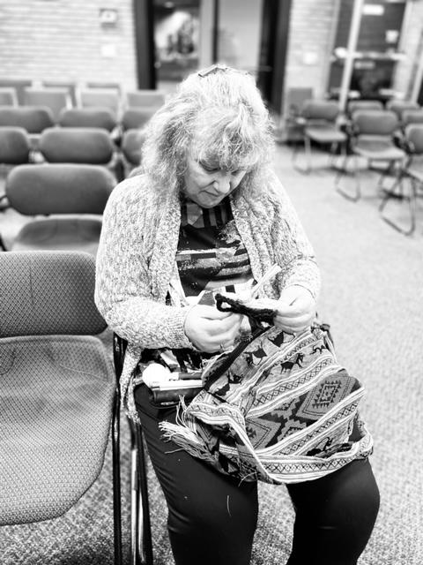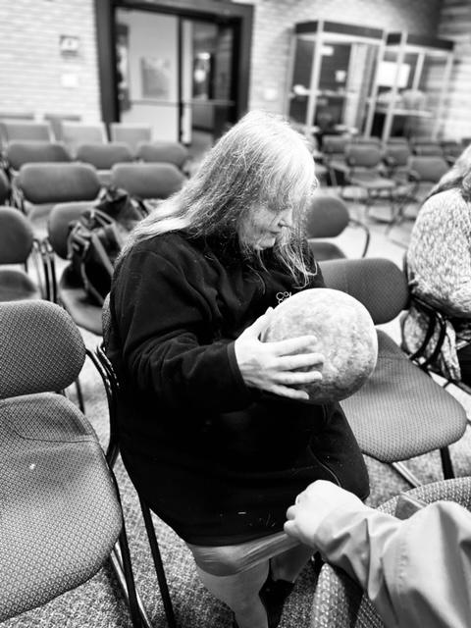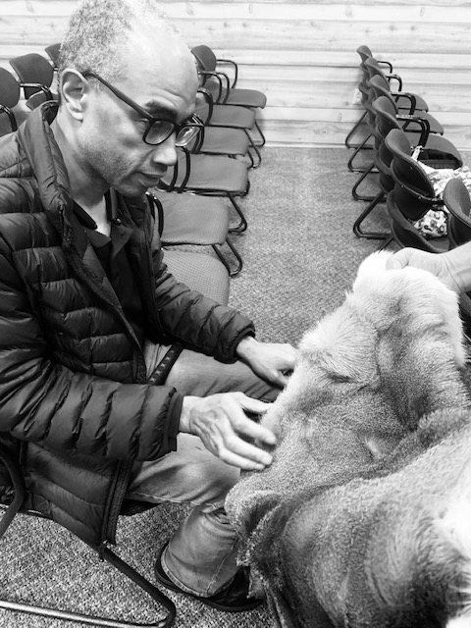
From left to right: Angela Zimmerman handling a woven bag; Sharon Nichols holding a ball made of animal hide; Steve Longmire handling an animal hide.

GLASS: Georgia Library
Kristin White told us about all of the new services that are available at the Georgia Library and told us about the new e-reader, which is an electronic reader that allows you to read braille through a downloadable device.
As the State Director of the Georgia Library Service for the Blind and Print Disabled, Kristin White is a graduate of Georgia State University with a Bachelor of Arts degree in history and Valdosta State University with a master’s in library and Information Science.

In addition, Kristin is also a 2016 graduate of the competitive Georgia Public Library Service/University of Georgia’s Carl Vinson Institute of Government PINNACLE program, where participants must hold a Master of Library Science degree, be currently employed in a public library in Georgia, and have at least two years of professional library experience. Over half of the program’s graduates have gone on to be library system Directors.” Having held previous positions with the Auburn Avenue Research Library on African American Culture and History, serving as Outreach Manager and Assistant Director of the Augusta (Georgia) - Richmond County Library System, and having served as State Director of South Carolina Talking Book Services through December of 2021, Kristin is happy to return to Georgia. This is the state where she was raised, and where she raised her only child, a daughter named Blaire.

Fire Drill:
During this session, the smoke and fire alarms went off, and everyone had to evacuate the building. It gave us an opportunity to look at the firetrucks and the cute firemen.

The Georgia Guide Dog Users group held their business meeting and presentation by speakers from K9 Battle Buddies, an organization on the Georgia coast that trains service dogs and veterans with PTSD and traumatic brain injury. The session was held in the hotel business library. Then, we held our Veterans’ Day Welcome Reception featuring Tyson Ernst, guest speaker, as well as other presentations and patriotic music in the Clarence Brown Conference Center.
Tyson Ernst was born July of 1969 in the High Desert city of Lancaster, in Southern California, surrounded by high tech aviation and aerospace. Only 3 days old when Neil Armstrong took mankind's first step onto the surface of the moon, Tyson says that is the reason for his love of space and science. At an early age, he also figured out he had a knack for teaching and conveying concepts to others so at the age of 16, in his garage, he began teaching private drum lessons. The next year this bloomed into teaching a junior high drumline and started a 25-year career in percussion education. Tyson entered the U.S. Army at the age of seventeen, as an infantry soldier and found another passion for strategy and competitiveness. After assignments at Ft. Benning and Ft. Hood with the 2nd Armored division and left the service in 1990. He found his way into medicine as a radiology technician, working at an urgent care before returning to his passion for teaching, this time in medicine. Within this career path, he suffered sight loss in 2005 and could no longer teach. Tyson returned to education, this time as a student at CSUN, where he earned a bachelor’s degree in history and Anthropology. But teaching called him again, and he began to undertake students as an access technology educator in 2015 where he still works for private students and VA clients. You may very well recognize his voice through his early work with the ACB community calls, his work with ACB media, including helping coordinate the 2020 GCB virtual convention.
On Saturday, November 12, 2022, we gathered for breakfast and held our GCB general session and business meeting in the Clarence Brown Conference Center.

During that GCB annual business meeting on Saturday, November 12, 2022, we watched the Color Guard which was presented by Boy Scout Troop 58 Fairmount, Georgia. Next, the GCB Chaplin, our own Fred McDade, lead everyone in the Pledge of Allegiance then gave the invocation. After the invocation, we paused to remember the following members and service animals who passed away this year. They included Ted Elders, Robin Oliver, Gaylon Lee Tootle, Wendy Wilson, and Cal Ritchhart (Alice Ritch hart’s service dog).

Ted Elders, husband of Savannah Council of the Blind long-time member Jan Elders, passed away on May 2nd this year at the age of eighty-one. Jan and Ted had retired to Tybee Island from Atlanta where Ted practiced law. Ted was born on March 6, 1941. He was a life-long Georgia resident. Ted faithfully droves Jan to SCB meetings and always attended the chapter's social events. He liked our Christmas parties best. Jan is adjusting to living without her life partner, and we all deeply miss Ted and his contributions to the Savannah Council of the Blind.

Robin E. Oliver, age 64, of Athens, Georgia passed away after a short hospital stay. Robin was born on October 8, 1957. Robin Oliver was a long-time member of GCB, who also served in the past as GCB Secretary and First Vice President. Robin was always ready to roll up her sleeves and get things done. She will be missed.

Gaylon Lee Tootle entered rest on Saturday, September 10, 2022. His fierce advocacy for the blind was known throughout Georgia. Wendi Elizabeth Wilson, 52, of Summerville, passed away on Monday, February 22, 2022, in a Rome Hospital. She was born in Floyd County, Georgia. Cal Ritchhart (Alice Ritchhart’s service dog,) In, January 4, 2011-October 4, 2022. Cal was an incredibly special guide dog. Cal was a graduate of the special needs program at Guiding Eyes. He came to live with me and my family and travel with me on May 6, 2013. He was not only my guide but was trained to help me with my balance issues. From the beginning he was always ready to work, and willing to guide me on many of my adventures. We attended many conferences such as GCB, and several ACB conferences. On one ACB conference he and I got to meet one of my idols Donny Osmond. It was truly “Puppy Love” as Donny got down on the floor with Cal and loved on him, and Cal being the out-going dog he was shared his puppy dog kisses with Donny. We also traveled to many U.S. cities, and on several cruises. At one city tour in CA. Cal decided to get nose to nose with a donkey at a winery. They hit it off, but me not so lucky as the donkey decided to bite me. I had to retire Cal in 2021 due to health issues, but Cal was not ready to be a stay-at-home dog. His next career was as the greeter for my son-in-law’s auto shop. He enjoyed saying hello to any customer who came in for car repairs. Sometimes he would sit in the garage just to oversee the guys to make sure they were fixing the cars right. Cal’s most favorite down time activity was swimming. He did not care if it was a pond or our backyard swimming pool he was there. Every summer he had to be the first one in the pool to check it out before anyone else. The last week of his life was no exception. I had taken him out so he could go to the bathroom, and when we returned to the house, I thought he needed to go back out. Imagine my surprise when I got to the door to the backyard and no Cal. Yes, the next thing I heard was a splash. He did his usual one lap around the pool, came running out and rubbed against me as to say I got my last swim In. I know that when Cal crossed over the Rainbow Bridge, he met his predecessors running and playing, and I am sure after romping with his brothers it was into a beautiful blue pond for a swim.

Cecily Laney Nipper, GCB president, asked Vickie Preddy, our Diamond Sponsor from Vanda Pharmaceuticals to speak to us about non-24. She is dedicated to raising awareness of Non-24-Hour Sleep-Wake Disorder (Non-24) and supporting the blindness community. Non-24 is a rare circadian rhythm disorder affecting up to 70% of people who are blind. People living with non-24 experience excessive daytime sleepiness and nighttime sleeplessness, which leads to impaired social and occupational functioning. This is due to the misalignment between the internal expert body clock and the 24-hour day.
Vicki Preddy is a Registered Nurse Educator for Vanda Pharmaceuticals. Her role is to raise awareness and provide education about non-24, a short name for Non-24 Hour Sleep Wake Disorder.
Cecily Laney Nipper, GCB, president gave her presidential report about what GCB has been doing the past year. Kathy Morris, GCB, secretary read the 2021 annual membership business meeting minutes. Marsha Farrow, GCB treasurer, gave us an update on our finances. Danielle McIntyre, Legislative chairperson, gave us an update on the Commission for the Blind Bill. Alice Ritchhart read the three resolutions for commission an independent absentee ballot voting system for GCB members: thanking the hotel and the convention center. Steve Longmire gave us an update on our GCB Link app, and Apple Pay. Marj Schneider gave us an update on what the Georgia Guide Dogs Users, GGDU, have been meeting virtually to discuss many topics related to guide dogs. During their business meeting this weekend they heard from K9 Battle Buddies, an organization on the Georgia coast that trains service dogs and veterans with PTSD and traumatic brain injury. Alice Ritchhart, the chairperson of the Alliance on Aging and Vision Loss new special affiliate in Georgia gave us an update on what they have been doing. They meet every month on the third Monday. They meet once a quarter to hold educational or informational meetings. We then adjourned our GCB business meeting.

Georgia Council of the Blind Annual Business Meeting in Person and via Zoom
Saturday, November 13, 2021
Presentation of Colors: The Presentation of Colors were presented by Cass High School JROTC. DJ McIntyre described the ceremony for us Pledge of Allegiance, Fred McDade: Fred led us in the Pledge of Allegiance. National Anthem, Betsy, and Michelle Grenevitch: Betsy and Michelle sang the National Anthem.
Call to Order, President Alice Ritchhart: Alice called the meeting to order at 9:06 AM.
Roll Call, Betsy Grenevitch: Those present were Betsy Grenevitch, Marsha Farrow, Jamaica Miller, Tiyah Longmire, Steve Longmire, Jennifer Bray, Charles Stubblefield, Fred McDade, Tonia Clayton, Amanda Wilson, Anne McQuade, Cecily Nipper, Sr., Cecily Nipper, Jr., Suzanne Jones, Judy Presley, Phil Jones, Robin Oliver, Jerrie Toney, Keith Morris, Kathy Morris, Michelle Grenevitch, DJ McIntyre, Debbie Young and Chris Holbrook.
On Zoom—Jeff Stump, Linda Williams, Alice Ritchhart, Valerie Hester, Kay McGill, Debbie McDonald, Shirley Robinson, Marj Schneider and Lisa Jones.
Invocation, Fred McDade: Fred led us in the invocation.
Happy Birthday: We sang Happy Birthday to Kay McGill.
Minutes, Betsy Grenevitch: Betsy made a motion seconded by Keith to approve the minutes as they were sent out and the motion carried.
Treasurer’s Report, Marsha Farrow: Cecily Nipper, Sr. read the Profit and Loss statement from Phyllis Waters. Income came from dues and registrations. The total income was $3390.53. General Fund Donations: $4071.01. Interest Income: $347.28; Total Received: $7808.92; Expense categories include: ACB membership dues, bank charges and fees, bookkeeping, computer and internet expenses, GCB awards, GCB conference and convention expenses, GCB _Digest, insurance, MaxiAids, office supplies and software and postage expenses. Total for Expenses: $6843.40; Net Operating Income: $665.52; Profit Income: $965.52. Next, Marsha gave the account balances. Main Checking Account: $7912.87, the Senior funds and Youth funds are also in this account. Senior Fund: $3349.05; Youth Fund: $640.48; Total of the two Funds: $3989.53. General Operating Fund: $3923.34; Conference and Convention Account: $4155.57; Al and Cora Camp Scholarship Fund: $119.91; Within this fund we have three categories which are the traditional scholarship for high school graduates, special scholarship for those attending conferences and the first-timers scholarship. We used some of the $302.50 for other scholarships and at some point, this will be replaced to go toward the first-timer scholarship. We will utilize our Way Financial investment to help fund this account as well. GCB CD: $5,072.16
This year, we received $69.63 interest on this account. GCB Long Term Investment: $16,860.19 and it matures on January 20, 2027. Jamaica made a motion seconded by Fred to accept the treasurer’s report for audit and the motion carried. Marsha made a motion to move funds from the general fund to bring the scholarship amount up to $302.50 which will be for the first-timer scholarship. These were funds that were raised in Savannah. The funds would come from the main account. Cecily Sr. seconded the motion and the motion carried. Liability Insurance: We have been with the Philadelphia Insurance Company for liability. Since August of this year, Marsha has been trying to find out the name of our representative but has not received an answer. They do not have anyone licensed to talk to us. We do currently have coverage for conferences. We do not have coverage if someone on the board does something illegally such as rob a bank. Marsha would like to ask for another quote from The Hartford since we have our liability insurance with them. Marsha made a motion that we proceed with the proper forms to get an insurance quote from The Hartford regarding liability for the board, fiduciary coverage, and website and app coverage seconded by Jamaica and the motion carried.
Project Independence, Kay McGill: Kay thanked us for our tribute to her that was held on November 12.
She explained that the Older Blind Program is for those 55 and older whose vision loss impacts their daily living. It is not a work program. The agencies who are providers for this program include: The Center for the Visually Impaired, Savannah Center for Blind and Low Vision, Vision Rehabilitation Services, Visually Impaired Foundation of Georgia, VISTAS—Visually Impaired Specialized Training and Advocacy Services and Walton Options.
In Georgia, we received $881 thousand for the fiscal year 2020-2021. We are one of the highest funded programs of the older blind here in Georgia in the nation. In the most recent fiscal year that ended September 30, we spent $932 thousand here in Georgia offering direct services to 1084 people. This came to $860 per person. The older blind program is not able to pay for aids and devices, but they can be obtained from other places. During the period of Covid they have been able to offer remote services. Kay thanked those who have been providing remote services during this time. Kay is retiring and her last official act will be the peer support group on December 1. She will be announcing on November 18 who will take over the program.
Vanda Pharmaceuticals, Vickie Preddy: Vickie explained the non-24 sleep/wake disorder. There is a low awareness of this disorder among the blind and medical community. This occurs due to the lack of light perception in the retina. It can occur in people with low vision or who have sight but at a much lower rate.
The symptoms for this disorder include trouble falling asleep at night, problems staying asleep at night and experiencing a lot of daytime sleepiness. Sometimes they want to sleep all day and stay awake all night. Vanda has a support center to help those who are experiencing these symptoms. You can reach Vickie at 407-963-4198. She is willing to provide education to chapters and support groups. Marsha thanked Vanda for contributing $1000 toward our conference and convention. She also told us that Democracy Live donated $500 and Dr. Mira Shivers donated $1000 to help people attend this conference and convention.
President’s Report, Alice Ritchhart: We were able to provide computers/iPad to our visually impaired students to be able to do school at home during the pandemic. Cecily Nipper, Jr. headed up this scholarship committee. We hope to continue to grow this fund so that we can help with other equipment for students in the future. We have been able to help older blind people purchase devices such as color identifiers and computers with JAWS and large print options. ACB’s Get UP and Get Moving: ACB is trying to get Medicare to purchase accessible devices that are needed concerning health needs such as the talking glucometer. Alice would like to start an Alliance on Aging and Low Vision group here in Georgia. Alice has been receiving calls from people needing resources. VR has reached out to us and wants to talk with members of GCB and NFB about the services for the blind in the state.
Constitution and Bylaws, Marj Schneider: Marj thanked Phil and Brent for serving on the committee with her.
Marj explained that our current documents did not offer ways for people to vote who are not physically present at a meeting. She gave highlights of some of the changes being recommended. After Betsy read the current and proposed changes Marj made a motion seconded by Phil to approve that the proposed changes to the Georgia Council of the Blind Constitution and Bylaws be accepted. The motion carried. Alice thanked Marj and her committee for their work on the Constitution and Bylaws.
Election of Officers: The slate of officers presented were Cecily Nipper, Jr.—president, Marj Schneider—First Vice-President, Judy Presley—Second Vice-President, Kathy Morris—Secretary, Cecily Nipper, Sr.—Assistant Secretary, Marsha Farrow—Treasurer, and Betsy Grenevitch—Member-at-Large Representative. President: Marsha moved that., Cecily Nipper, Jr. be elected as president of GCB by acclamation and the motion carried. First Vice-President: Deborah Lovell made a motion that Marj be elected by acclamation for first vice-president and the motion carried. Second Vice-President: Marsha made a motion that Judy be elected as second vice-president by acclamation and the motion carried. Secretary: Deborah Lovell made a motion that Kathy be elected secretary by acclamation and the motion carried. Assistant Secretary: We did not vote on her since it is not a position listed on our board. Marsha moved and Cecily Nipper, Jr. seconded that we appoint Cecily Nipper, Sr. to be the assistant secretary and the motion carried. Treasurer: DJ made a motion to accept Marsha as treasurer by acclamation and the motion carried. Member-at-Large Representative: Deborah Lovell made a motion that Betsy be accepted as the Member-at-large representative by acclamation and the motion carried. Alice thanked Jerrie and her committee for serving on the nominating committee.
GCB App, Steve Longmire: Tiyah Longmire introduced the GCB app which will work on both the iPhone and Android phones. The same information that is on the website is available on the app. You can make a phone call or send an email from this app. Steve demonstrated the app for us. He thanked everyone who helped him work on the app and made it possible.
GGDU, Betsy Grenevitch: Betsy told us that GGDU met via Zoom in May and in person on November 12. She also told us about the officers who were elected at the recent meeting. They are: Marj Schneider—president, Cecily Nipper, Jr.—Vice-President, Betsy Grenevitch—Secretary, and DJ McIntyre—Treasurer.
Thank You, President Alice, Cecily Nipper, Jr.: Cecily thanked Alice for all she had done dure her presidency of GCB. She will be receiving a gift card to her favorite restaurant as a token for our appreciation for everything she has done for GCB.
Alice thanked Cecily for the great job she did with the conference and convention.
Door Prizes: Jamaica and Jennifer gave out door prizes.
Adjourn: We adjourned at 11:06 AM.
Respectfully submitted by
Betsy Grenevitch, Secretary

Shirley Robinson, with Project for Independence gave us an update on her work with individuals who are blind who are seeking assistance in Georgia to find jobs or to be more independent in their communities. Shirley M. Robinson MS. CRC C, coordinator of Blind Services, Vocational Rehabilitation, Shirley Robinson has served within the blindness community for 20+ years. After earning her master’s degree and CRC In 1997, from Georgia State University she began her career as a vocational Specialist with the Center for the visually impaired in Atlanta. This led to her present affiliation with the Georgia Vocational Rehabilitation Agency, vocational rehabilitation program where she served as a Certified Rehabilitation Counselor. In 2008, she completed the Vision Specialist Certification PROGRAM THROUGH Mississippi State University’s Graduate Studies program. Then In April 2009, Shirley Robinson was promoted to the position of Rehabilitation Unit Manager for the Metro Blindness Services Unit. In September 2016, Shirley Robinson was promoted to Service Area Manager overseeing the DeKalb and Rockdale County Areas. Then in October of 2017, she was promoted to Assistant Director of Blind Services. Most recently, in October 2020, Ms. Robinson was promoted to Coordinator of Blind Services with GA VR.
Aside from trainings, Ms. Robinson serves as the Employment Committee Chair with the National Council of State Agencies for the Blind, and Board Member of the National Rehabilitation Professionals Division of the National Federation of the Blind. In addition, she sits on the advisory boards with Tools for Life and the Audible Universal Information Access Service. Ms. Robinson was also the 2018 and 2019 President of the Georgia Rehabilitation Counselors and Educators Association Division. Her passion is assisting the blind community and developing methods for improving the lives of individuals with disabilities in Georgia.

Donna Brown, American Council of the Blind, ACB, gave us an update on what ACB had been past year. She gave us a four-part word to remember. PART, have p
passion for your selected activities; advocate for groups you believe in; find resources to assist yourself and others; and thank
Donna Brown was elected to the ACB Board of Directors for an unexpired term in 2020 and then 2021 for her first official term. While now living in Romney, West Virginia, Pottstown, Pennsylvania is the town where Donna grew up. She attended the Overbrook School for the Blind K-12. Kutztown University in Pennsylvania is her alma mater with a double major in a Teacher of the Visually Impaired program and Elementary Education. After applying for any openings in surrounding states, Donna took a job at the West Virginia School for the Blind where she taught for 37 years.
Donna has three siblings, two of whom are blind, and her mother lives with her in West Virginia. Donna has two nieces in Virginia and Texas. Around 2011 Donna was elected president of the Mountain State Council for the first time, serving three two-year terms. With her free time, Donna is the Sunday School Director and sings in the choir at Covenant Baptist Church. She is a member of the Romney Lion’s Club as well as serving on the board of the local sheltered workshop.
Then, we held our annual GCB Awards’ luncheon in the Clarence Brown Conference Center. Amanda Wilson gave the invocation. Steve Longmire introduced Matt Simpson.
Matt Simpson, spoke to us about being a young boy with a visual impairment trying to participate in sports. Matt Simpson has represented Team USA at two Paralympic Games in the sport of goalball. He helped Team USA win a silver medal in the 2016 Rio Games as well as bronze in the 2014 Goalball World Championships, along with numerous other top three finishes at major international events. He continues to compete as a member of the men’s national goalball team and will be representing the USA at the 2022 Goalball World Championships in December in Portugal. He is a 2020 graduate of the University of Virginia Law School and is an associate in the Washington D.C. office of law firm Sidley Austin in its White Collar: Government Litigation and Investigations practice. Prior to joining Sidley, Matt worked as an associate counsel to the Senate Judiciary Committee. He previously worked in the nonprofit sector doing national outreach and education for blinded veterans and teachers of the visually impaired. Most important, he is a husband and father to Nellie, 2, and Sammy, 4 months.

Presentation of GCB Service Awards:
Marsha Farrow, Debbi Young and DJ McIntyre gave out the following GCB service awards. The Rhonda Walker service award was presented to James “Jim” Tilson. Betsy Grenevitch nominated him. The Gerald Pye service award was presented to Deborah Lovell. Mike Hall nominated her. the June Willis Guiding Eyes service award was presented to Cecily Shivers Nipper, Senior. Cecily Laney Nipper nominated her. The Walter R. McDonald Distinguished Service Award was presented to Cecily Laney Nipper. Alice Ritchhart, Keith Morris, and Marsha Farrow nominated her. An Award of Innovation was presented to Danielle “DJ” McIntyre. Marsha Farrow nominated her. A Presidential Diamond Award was presented to Amanda Wilson. A President’s Diamond Award was presented to Marsha Farrow. A President’s Platinum Professionals Award was presented to Nancy Parkin-Bashizi.

Finally, we held our short GCB board meeting to close out the GCB convention.

Georgia Council of the Blind Convention Comments:
By Phil Jones

We talked about it for months! For months we had planning meetings! Then there was the Convention! It came and went! Did all the work pay off? I will answer that question later! On Thursday evening November 10th we got off to a rip-roaring start with a super bingo night complete with fun, games and good things to eat! The next morning the membership was introduced to our new Special Interest Affiliate of the Georgia Council of the Blind Alliance on Aging and Vision Loss. Following that we had two informative Sports presentations about Blind Golfers and Kayaking! We also had some fine Exhibitors. The Georgia Library presentation. It was Great! During that presentation we had to evacuate the hotel for a few minutes due to a water leak on the fourth floor. The veterans Reception that evening was excellent, especially the speech about the military and leadership! The next morning, we had a well-organized business session! After that we heard a very inspiring speech from American Council of The Blind Board Member Donna Brown.

Our Awards Luncheon was as usual very enjoyable. Congratulations to all our Award winners. As with last year's Convention people participated in person and virtually which went very well! I personally thank those people who assisted me with bingo night, all the presenters, exhibitors, the Dynamic Convention Committee and of course the wonderful Staff and Management of The Courtyard Marriot Hotel! If any of you have not guessed already, I thoroughly enjoyed the convention! Did all that talking, planning, and working pay off? If you are looking at it from my point of view, do I need to say more?

Our Octogenarian Odyssey
By, Janet DiNola Parmerter
Odyssey: A long series of adventures especially when filled with notable hardships. Yes, I believe anyone who is a caregiver may accurately define their efforts as an odyssey. Certainly, my husband Keith and I called living with our three over 80 octogenarian family members a long series of adventures. Unequivocally, we called it, “Our Octogenarian Odyssey.”

It began nine years ago when we moved my mother’s sister, Auntie Rena, from my parent’s residence in New York to our New Jersey home. Recently, due to illness, my parents also relocated here, completing our happy household of now, three octogenarians, my mother’s feisty cat Gatto (which means cat in Italian), we two somewhat patient caregivers, and our own nervous octogenarian cat Maynard. Above the door for our elderly cat hangs a leather sign we purchased in Orvieto, Italy, which reads, “In questa casa siamo TUTTI nervosa…anche il gatto!” Those words are the most ‘PURRRR-FECT’ words to sum up our current living arrangements. Fittingly it translates into, “In this house we are ALL nervous…even the cat! This clever saying is written under a picture of a frightened black cat with an arched back and its fur and tail standing straight up.”

Under this roof some say the level of excitement is more than one house could stand. Nevertheless, each truss holding up this roof is secured with a good balance of humor and laughter, and this is especially evident with Auntie Rena, my mother’s oldest sister. She is an 89-year-old, five-foot two-inch strong, non-eye glass wearing woman, with at least two pink rollers always in her short white hair. She never married because she never wanted to burden a husband with what she called her, “little problem.”

You see, from eleven years old she suffered with epileptic seizures; therefore, she turned down any prospective suitors and became a teacher of the Bible. Even with epilepsy, she was a sweet, gentle, resilient woman, until dementia slowly diminished her intelligent brain and made her somewhat angry. Teaching the Bible filled her life with intense joy, and now, practically her only memories are Bible scriptures. Sadly, her doctor said so many of her brain cells died because for 78 years, she fought taking her epilepsy medicine. The fact that her constant seizures caused brain cells to keep dying, just didn’t register.

Before being health conscious was fashionable, Auntie Rena was one of the first health nuts. She ate all natural foods, used garlic for everything, made her own yogurt, and knew every vitamin and herbal remedy to make you feel better. Yet, she had to be forced to take her Dilantin and flushed most down the toilet saying, “I prefer doing things my way rather than having the side effects of that nasty medicine.”

That began Keith and my war of the pills. Each day we mapped out a strategy to sneak Aunt Rena Dilantin to prevent her seizures. At first, we actually thought she took each pill, but later my husband discovered pills in the sink and the garbage pail. That first battle was won by Auntie Rena, so we plotted a new tactic to ensure success. After she put the pill into her mouth, we stood in front of her until she swallowed it. At last, we won! Well, I suppose I should say we thought we won. It wasn’t long before my daughter found dozens of pills clustered together in her sweater pocket. Yes, huddled together were dozens of little white Dilantin pills, which all started out blue, but now had various stages of the blue coating dissolved. Cleverly, Auntie Rena kept the pills in her mouth until she felt safe, then slyly slipped them into her pocket. Another battle lost for our side, but we were not defeated yet. With a mortar and pestle, I crushed the pill and mixed it into a chunky peanut butter sandwich. Before I could high five Keith, I saw her pick out something from her mouth, put it on the table, open her sandwich and begin picking out tiny bits of the pill. It was another depressing defeat for the not so dynamic duo, Keith, and me.

Again, feeling defeated by this frail elderly spinster, I phoned the doctor and explained our frustration with regards to the crushed pill situation. He suggested a liquid prescription which could be easily blended into her food. Immediately we added the medicine into soup, drinks, and oatmeal. Unfortunately, she told us her food tasted awful, and protested, “Eat it yourself!” Score, Auntie Rena 4, the pill pushers 0.

Suddenly, I was ready to celebrate because I had a brilliant Idea. The next day I phoned the doctor and requested the children’s medicine, a cherry flavored liquid Keppra. Each day I folded back the foil on cherry yogurt and Keith mixed in the cherry flavored Keppra, replaced the foil, and Auntie Rena thoroughly enjoyed each cup of yogurt.

Ready to sing our victory song, we felt sure this battle was won. That was until one day, when Auntie Rena shot Keith in the back. Well, not literally, but in the war of the pills, it was an emotional shot to his pride. Weeks later, she caught him mixing her yogurt with a spoon, became suspicious and completely stopped eating. Aunt Rena no longer trusted anything we gave her to eat. Starvation or medicine, what a dilemma. Even more frustrated, the doctor sighed, “Look, she’s 85 years old, why are you battling her? She hates hospitals, doctors, medicine, and especially me! She does not listen to you, and she certainly does not listen to me, or for that matter anyone else. Just let her be happy and let her do what she wants to do.” Consequently, we held up the white flag and surrendered to Aunt Rena’s stubbornness. So here we are today, she has multiple daily seizures, says she does not, and she is happy because she never remembers a thing. All her horrifying falls remain in our minds and sad to say in the minds of our little grandchildren. When Auntie Rena had a seizure at the top of a flight of stairs, rolling down eighteen hard oak steps in front of my granddaughter, she was terrified and thought Auntie Rena died.

So often, my aunt has repeated the words, “I’d rather have my little problem than all those nasty side effects from medicines that kill people!” Kill people? Talk about killing people ---we are so happy she never killed anyone or herself. For example, how thankful we were no one was in the yard when Aunt Rena blacked out in her car and mindlessly drove through a neighbor’s front gate. That day my mother took her car keys, gave the car to Uncle Louie, and Aunt Rena, who said she didn’t drive through anything, was furious.

For my part, all my life I worried about her injuries from her terrible falls. The vivid teenage memory I have of hearing a crash, then seeing Auntie Rena lying under the kitchen table shaking with a knife clutched in her hand still haunts me. Yet, she constantly denied having any seizures at all.

Consequently, as the doctor said, since brain cells died with each seizure, the more she didn’t take her medication, the more seizures she had, and the more brain cells died. That vicious cycle caused her dementia, and little by little took away my beloved Aunt. Each morning she climbs the back stairs, enters our kitchen, and quietly repeats the same questions. “Where are we?” This is usually followed by, “Do I live here, and then what am I doing here?” After a brief moment, the next question pops up, “Oh, and deary, what day and month is this?” Every day, with the exception of the date, her repetitive questions are answered the same way. After she is told the state, she stares into space and repeats it twice as if we told her she lived on Mars. After hesitating a few seconds, curiously she would ask, “What am I doing here?” Shocked, when hearing she has lived here three years, she becomes visibly embarrassed. That always sparks the ritual of wildly waving her arms over her head and spinning around to run away. Stumbling as she loses her equilibrium she begins mumbling, “I’m lost…I’m confused!”

Aunt Rena will then spend the next hour going in and out the back door about three or four hundred times. When she decides to rest on the back deck, she gives all eight chairs a 30 second to one-minute try, and then begins the rounds again.

Recently, conversation has become a thing of the past, but her most predictable comments are about not wanting to eat and that food cost too much. Since she is always obsessing over money and becoming fat. This could be since her sister Enes, at five feet tall was a hefty 390 pounds. Therefore, fat has been a constant family struggle which may contribute to her ‘fat fear’. Once, after Keith found her antibiotics in the sink, like a caught child she flippantly waved Keith off and said, “You just want me to take that pill so I can get fat like you!” With her dislike of eating food, she acts as though eating is an unnecessary frivolous chore. When I call her to a meal, her first words are always, “Oh do I have to eat?” Usually, I chuckle and respond, “Well, you don’t have to eat, but death is the alternative, so I think eating is a better option.” Three times a day, when we place her plate in front of her, no matter how much food is on it, she turns her head and robotically waves her hand while saying, “Oh no, I could never eat that much!!! Please just give me half!” To test her reaction once I actually placed one pea on the plate. Yes, one pea! After setting the plate on the table, I received the usual, “Oh, no deary, I could never eat that much,” Quickly I responded, “Auntie Rena, I put one pea on the plate, I think you can eat the whole pea, try and force it down!” When she finally looked at the single lonesome pea on the huge plate, she laughed, and then as if I had some all-knowing answer she curiously asked, “Why did I say that?” Good question, but then, after complaining about the amount of food on her plate, she eats every bit. Since we discovered she would sneak more food if we weren’t looking, we turn our heads away from the table and let her sneak the food from the center or even off our plates.

Whenever we take her out, we tell the hostess not to give her a menu or she won’t eat. Once she sees food cost more than it did in 1945, she refuses to order anything but water. At McDonald’s, she ordered a cheeseburger, glanced up to the menu, immediately canceled the order and complained, “Your prices are terrible!” then added, “Just bring me a milkshake.” The young man took back the burger, placed the shake on the counter, told her the price, then she yelled, “What? If you think, I am paying that for milk, you're crazy! Young man you can just put it back and get me a cup of water!” Trying to calm her down I said, “Now Aunt Rena, he can’t put the shake back, it’s already poured, why don’t you just take it?” With folded arms, she turned her head and stopped speaking. That is her way of saying,
“Your words are going in one ear and out the other, because I won’t budge!”

Now, with my parents also living here there are new family dynamics. Apparently, 64 years ago, dad never forgot Rena wanted mom to marry someone else. It had been long gone from Rena’s memory, but not dads. Since my parents moved in, the tension thickened as Rena started getting under Dad’s skin. Everyone’s nerves were thinner than usual. Even our octogenarian cat Maynard tried to find peace by hiding under our bed. Dad was convinced Aunt Rena was putting on a huge act, pretending to be unstable as, ‘A clever way to have us cater to her every need.’

This paranoid frustration increased since he was convinced mom was being duped by her older sister and he was the only one who could see through her deception. Before he moved in, I cautiously warned him, “Daddy, if you keep telling my friends there is nothing wrong with Aunt Rena, they are going to think something is terribly wrong with you, not her. Everyone here knows something is wrong with her mind!”

For example, when Uncle Dan enlarged our deck, I moved the heavy iron chairs off the deck to the far end of the yard. Mysteriously, every morning all the heavy wrought iron chairs neatly lined up outside Aunt Rena’s door. Now I know they did not roll there by themselves, so I asked 110 pound, quiet, Aunt Rena, who was sitting on her patio swing, “Why did you bring my chairs here?” Uninterested in my question, she turned away and kept swinging forward and back. Again, I asked, “Aunt Rena, why did you pull my chairs here? I don’t want to keep moving these heavy chairs, they are too heavy!”
She stopped swinging, turned her head away from me then tersely said, “Stop complaining!” Shocked, I bit my tongue once, then again before I laughed.

Claiming she needs fresh air to breathe, in winter when the temperature is four degrees she has the windows open to allow fresh air into her room. When Keith peeked in, he saw her sleeping with a babushka towel wrapped around her head, socks on her hands, and so many blankets she could hardly move.

In contrast, when it is 97 degrees outside, she sits reading a magazine by her open screen door. Meanwhile, the air conditioner is ready to explode as it struggles to cool the entire state. My granddaughter Sydney closed the door three times in thirty minutes, and when the astronomical bills were mentioned she calmly said, “I’m sorry dear…Well, just remind me to keep the door closed.” Sydney suggested pasting bright orange reminder signs on both sides of the door, so she printed up, “Keep the door closed, air conditioning is on, and we lose lots of money when the door is open.”
It did not help! In an ornery mood, she yelled, “We never had that fake air when I was young…We had real fresh air! Just shut it off and leave me alone!” Trying to appeal to her sense of justice, I said, “If we didn’t give you heat or cool air, the police could take us away and put us in jail for not taking good care of you.” Snapping her head away, she sarcastically said, “You are making that up. No one will do that, just let them try.” Ironically, she was such a sweetheart, a quiet, polite, kind, non-imposing woman, now, after she has an angry attitude, it is always followed by a terrible seizure.

After all this, dad confoundedly states, “She’s just a good actress, she’s fooling all of you but not me! She just wants to be waited on and she pretends not to know things just to get her own way.” Resigning myself to the fact that my father will never believe she has a problem. With the household Freudian dynamics, life has been quite humorous. This evening while having a seizure, Auntie Rena shoved an entire napkin in her mouth. Everyone raced to get it out of her mouth so she wouldn’t suffocate, but she clenched her teeth together so tight, we could not open her mouth. The last time I dug into her mouth she bit me, so naturally I proceeded with caution as Rena began mumbling in Italian. Dad sat on the recliner saying, “Don’t worry, she won’t choke, she’s just faking it! Mom shouted, “John, stop that, my sister is going to choke,” and dad came back with, “Alice, she’s got you so duped, look at her she’s just doing this for attention.”

Meanwhile, Rena was oblivious to everything, and concentrated on chewing the huge ball of paper in her mouth. Even though she no longer spoke Italian, she continued mumbling Italian words, which was the customary practice whenever she had seizures. It was strange, but when having a seizure, she reverted back to the language of her childhood. Uncle Dan said hold her nose and she will open her mouth. Anna Mae sat on the other side ready to grab the napkin as Rena barely parted her teeth. Still, Anna Mae managed to pick out a few pieces as Rena yelled in Italian, “It’s mine! It’s not yours, it’s mine, it’s mine!” Answering her in Italian, I held down her fighting hands and said, “Now Aunt Rena, that’s not yours it’s hers! It’s not yours!” (Non e tua, e sua!) In a split second, she came out of the seizure, opened her mouth, and in clear English said, “What are you talking about; I don’t understand what you’re saying!” It was hilarious. We all started laughing and immediately felt relief. Yes, laughter not only helps endure tricky situations, but it’s healthy.

Sadly, a few years ago we had to place Auntie Rena in a nearby nursing facility. Unable to walk or communicate properly, she thinks I am my mother and when I said Keith was not my father, she said, “Who are you kidding, you’re not fooling me, I know he is John.” At that time, she was 92, and thought she was 70. When I told her how old I was, she asked, “Then how old am I?” When I answered 92, she loudly exclaimed, “92? 92? What am I still doing here? I should be dead!” That was some years ago, and in a few months Auntie Rena will be 100 years old. She has had Covid twice, pneumonia and numerous infections, but the old girl is still going strong. After writing this article some ten years ago, on November 30, 2022, four months before my Auntie Rena turned 100 years old, she quietly fell asleep in death While reading these humorous memories of my Auntie, we came to realized laughter indeed is the best medicine. So please enjoy some laughter and memories with Keith and me.

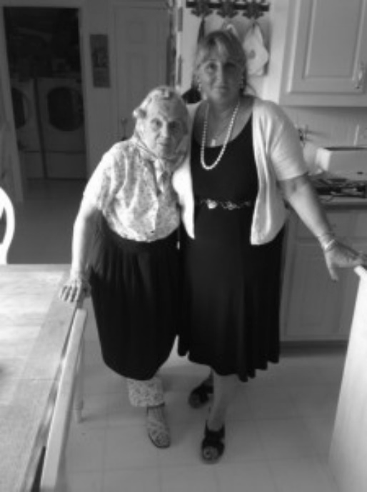
Aunt Rena and her niece Janet

The End

